Name: ____________________________________

Can you match the parabola using www.Desmos.com ?

Try to make reproduce the same parabola and write down your equation.
(Hint: you can use the “parabolas vertex form from yesterday)

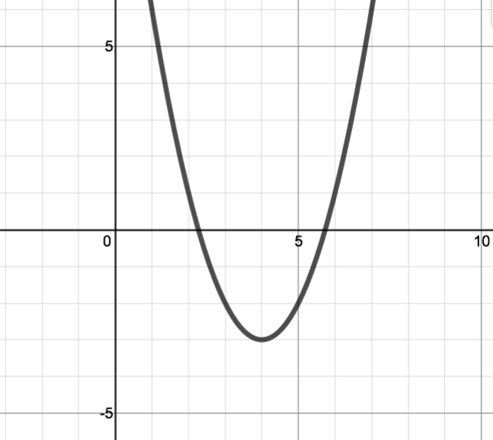

- Equation: __________________________________
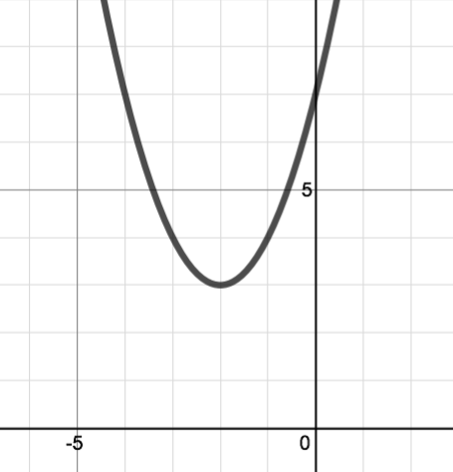
- Equation: __________________________________
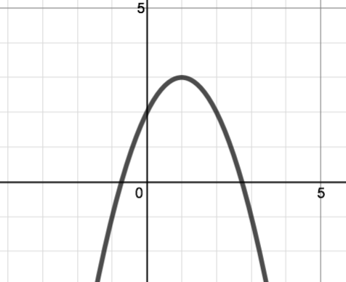
- Equation: __________________________________
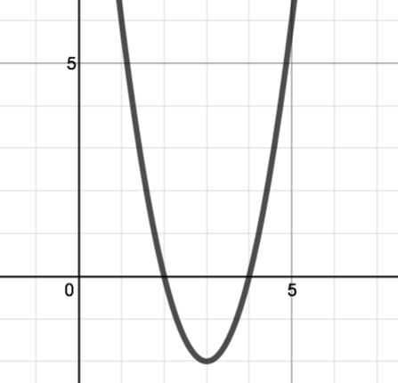

- Equation: __________________________________

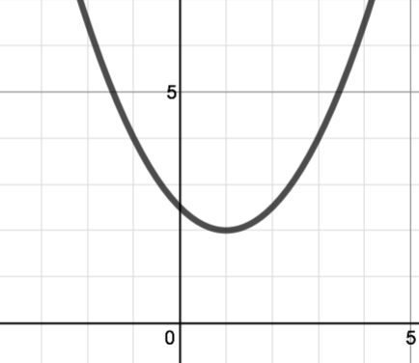

- Equation: __________________________________

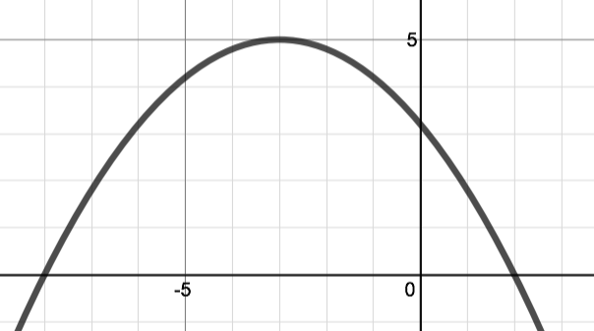

- Equation: __________________________________

